Chinese Trade Expansion Memorandum
Trade is probably one of the easiest ways we in the West can see China’s growing influence on a day-to-day basis. My team and I decided to find out how China’s soft power influence was growing and which parts of the world it would likely focus their efforts. In regards to trade, China’s import and export totals have skyrocketed since the 2000’s, especially noteworthy being their focus on Sub-Saharan Africa and the Middle East. Based on our findings, we see a clear trend of China continually asserting its influence over those regions.
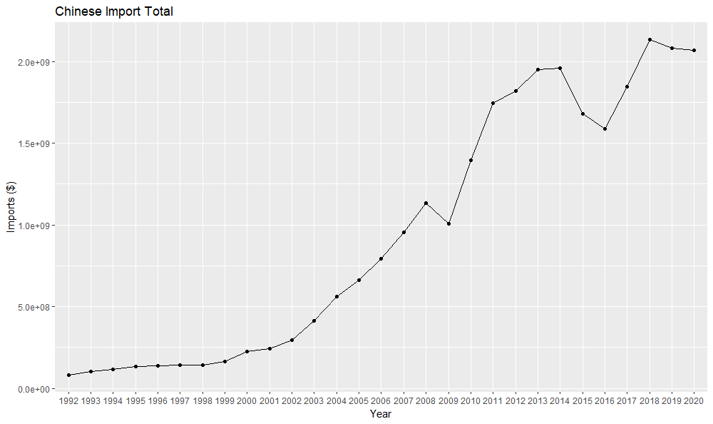
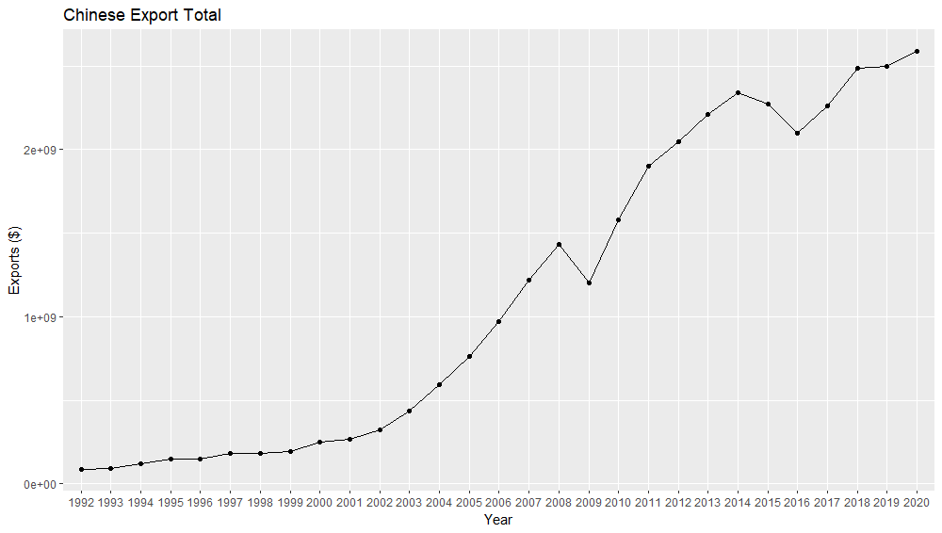
To confirm China’s growing trade influence over the rest of the world, we have compiled total import and export data since 1991.

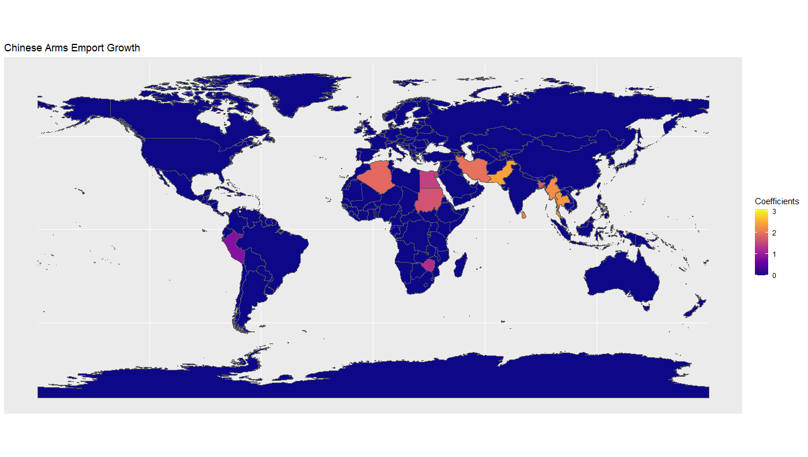
These figures are consistent with our hypothesis, showing a sharp increase starting in the early 2000’s. It is worth noting that the exports have always slightly outpaced their import totals. This is likely a byproduct of China’s focus on leveraging their large workforce population to manufacture and produce on a level that cannot be matched by almost any other country. Next, we decided to hone in on arms trading. We compiled data on accessible arms trading data with China and every other country to compile a geographical image of which parts of the world were seeing the most growth in their trade with China.

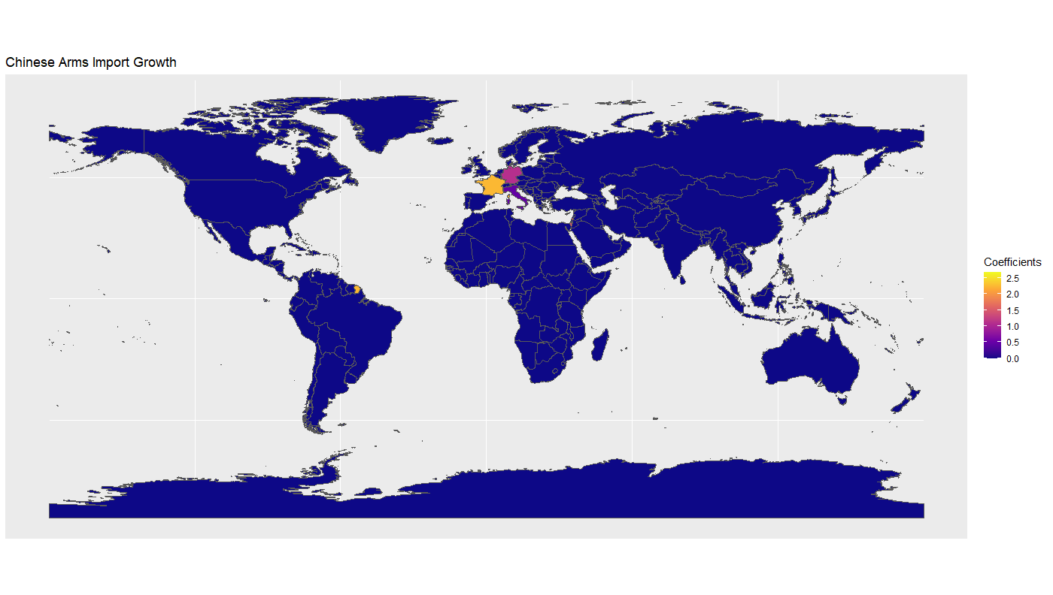

These maps show a clear pattern of China importing Western produced arms and exporting to African and other Asian countries. What this implies is that China, in return for these exchanges, prioritizes different commodities depending on the region.
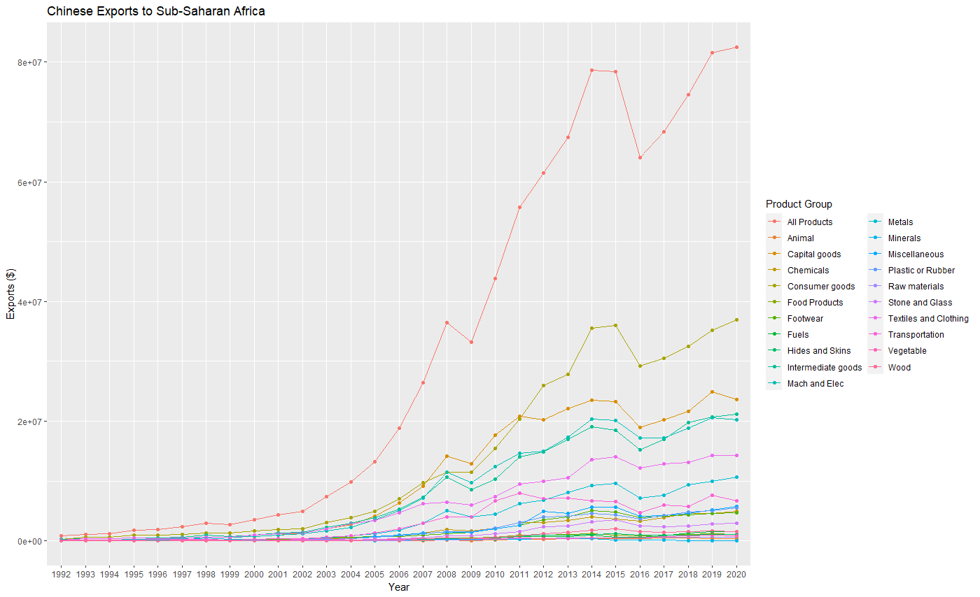
To illustrate this, we decided to focus on trade to Sub-Saharan Africa, a clear benefactor of Chinese trade priorities. We found import and export data specific to product type.

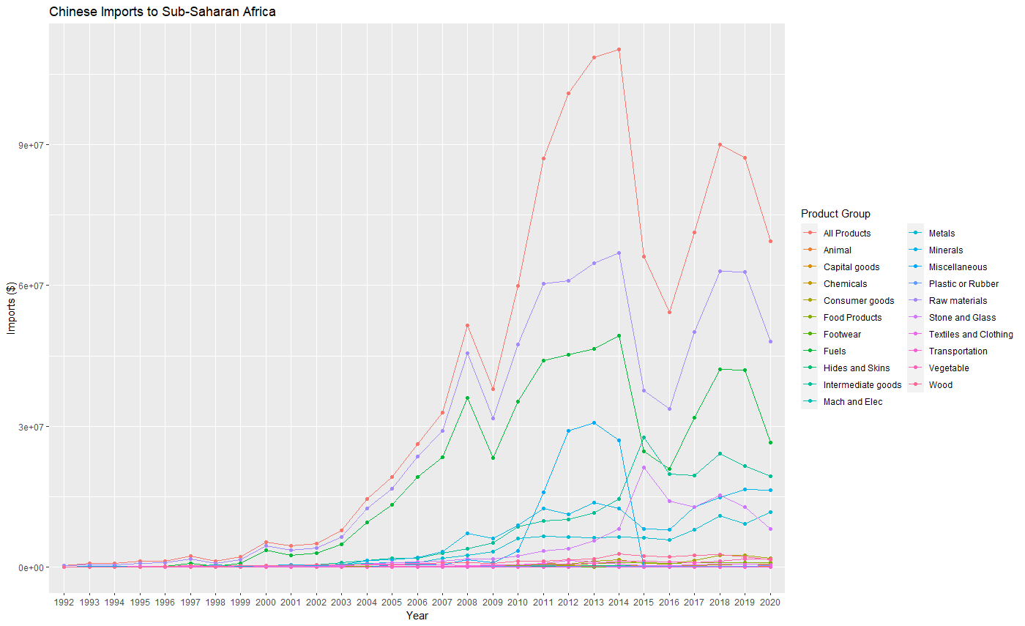

It is clear that China is looking for very specific products from this region in exchange. China is exporting what they have an abundance of due to their unparalleled ability to manufacture and farm and a large scale. This is shown with their main exports being livestock, capital goods, and other manufactured goods. In return, China gets natural resources they otherwise would not have nearly as much access to. In addition, China chooses these countries as trade partners due to other political factors that are out of the scope of this memorandum.
From the data shown above, it is clear that China targets specific materials in their trade endeavors and can do so as a result of their wealth and manufacturing power.

